Yale University
Emergency Action Plans
2017-2018
Table of Contents

Injury/Illness Emergency Protocol 2
Yale University Emergency Action Plans 3
Payne Whitney Gym 3
Map & Directions to Yale New Haven Hospital 4
Ingalls Rink 5
Map & Directions to Yale New Haven Hospital 6
Yale Bowl 7
Map & Directions to Yale New Haven Hospital 8
Smilow Field House 9
Map & Directions to Yale New Haven Hospital 10
Coxe Cage/Cullman Tennis Center 11
Map & Directions to Yale New Haven Hospital 12
Dewitt-Cuyler/Clinton Frank Complex 13
Map & Directions to Yale New Haven Hospital 14
Dewitt Family Field 15
Map & Directions to Yale New Haven Hospital 16
Yale Field 17
Map & Directions to Yale New Haven Hospital 18
Johnson Field 19
Map & Directions to Yale New Haven Hospital 20
Reese Stadium 21
Map & Directions to Yale New Haven Hospital 22
Gilder Boathouse 23
Map & Directions to Yale New Haven Hospital 24
Yale University Lightning Protocol 25
Yale University Extreme Weather Policies 26
Cold Weather Policy 28
NWS Windchill Chart 29
Cold Exposure Guidelines 30
Hot Weather Policy 31
Relative Humidity Chart 32
Heat Stroke & Exhaustion Signs and Symptoms 33

Injury/Illness Emergency Protocol

Medical Emergencies Chain of Command
Team PhysicianAthletic TrainerContest ManagementCoachesAthletesBystander

** Most often, it will be the Athletic Trainer’s job to activate any Emergency Protocol deemed present at the time.

** FOR ANY VISITING TEAMS/ATHLETIC TRAINERS, please call sport specific Yale Athletic Trainer for ANY/ALL emergencies after activating EMS.

1A. Immediate care of the injured/ill athlete if Athletic Trainer present

Check ABC's, Severe Bleeding (w/blood exposure, follow OSHA guidelines), Gross Deformities and Level of Consciousness.

IF ANY of the ABOVE are COMPROMISED ACTIVATE EMS by calling 911

RESPOND TO ANY COMPROMISED FUNCTION
Begin Rescue Breathing / CPR if needed or administer necessary first-aid care
If spine board is needed, or an ambulance is necessary, activate EMS and call 911.
If splinting is not possible, stabilize and comfort athlete until EMS arrives.

NOTE: If cervical injury is suspected and individual is breathing and/or conscious, and ambulance response time is short, instruct victim to remain motionless and manually stabilize and maintain c-spine stabilization.

1B. Immediate care of the injured / ill athlete if Athletic Trainer NOT Present
There shall be at least one trained individual at all practices, competitive events, conditioning, and skill sessions. The minimal training is CPR and the prevention of disease transmission (blood borne pathogens). These individuals include the ATC, athletic training student(s), strength and conditioning specialists, coaches, and contest managers. Appropriate emergency first aid steps must be taken in accordance with the level of certification that each trained member of the emergency care team has.

Check ABC's, Severe Bleeding (w/blood exposure, follow OSHA guidelines), and Levels of Consciousness.

IF ANY of the ABOVE are COMPROMISED ACTIVATE EMS by calling 911

RESPOND TO ANY COMPROMISED FUNCTION
Begin Rescue Breathing / CPR if needed or administer necessary first-aid care

**See venue specific instructions for EMS access. **

Yale University Athletic Training
Emergency Action Plan
Payne Whitney Gym
70 Tower Pkwy, New Haven, CT 06518

Emergency Personnel: A certified athletic trainer (ATC) is on-site for practices and competition. Athletic Training Student(s) may be present only when supervised by an ATC. A Physician/PA will be present for Men’s and Women’s Basketball and Gymnastics contests.
Emergency Communication: Cell phones and landlines are available in the Dwyer Athletic Training Room (ATR) located on the first floor of the Payne Whitney Gymnasium, as well as at the front desk and with the on-site athletic trainer.

Jay Cordone (Head Athletic Trainer) c:(914) 494-9352
Lindsay Snecinski (Volleyball, Swimming/Diving, MCrew ATC) c:(203) 464-8848
Brandon McDonald (Men’s Basketball ATC) c:(973) 650-9380
Nicole Payne (Women’s Basketball, Women’s Crew ATC) c:(914) 522-5212
Jenny Conrad (Gymnastics ATC) c:(541) 968-3305
Kelsey Jensen (M+W Fencing ATC) c:(719) 242-5795

Police/Fire/EMS 911
Dwyer ATR o:(203) 432-2467
Yale New Haven Hospital Emergency Room (203) 688-4242
Yale Security (203) 432-4400

Emergency Equipment: First aid supplies (athletic trainers’ kit and body substance isolation (BSI) bag) on-site. Breathing devices, vacuum splints and crutches are available in the Athletic Training Room (ATR) located on the first floor. AEDs are located in the ATR, in the lobby and on the 4th floor in the Israel Fitness Center. During Varsity contests emergency equipment will be located at the event site.
Roles of Emergency Care Team Members
- Immediate care of the injured/ill student-athlete: Follow appropriate first aid principles (See Injury/Illness Emergency Protocol included with this Emergency Action Plan).
- Emergency equipment retrieval: Appropriate to the emergency
- Activation of emergency medical system (EMS) by calling dispatch at 911.
  - Provide them with the following information:
    - Identify yourself and your role in the emergency
    - Specify your location and telephone number (if calling by phone)
    - Give name(s) of injured/ill individual(s)
    - Condition of victim(s)
    - Time of the incident
    - Care being provided
    - Give specific directions to the scene of the emergency
Direction of EMS to the scene
- Open appropriate doors
- Designate individual to "flag down" EMS on Tower Parkway or meet EMS in main lobby of PWG and direct to scene
- Scene control: keep non-emergency medical team members away from the scene

*In the event of an emergency in the pool, coaches and other team related individuals who are certified as lifeguards and qualified in water-rescue situations will take the lead.

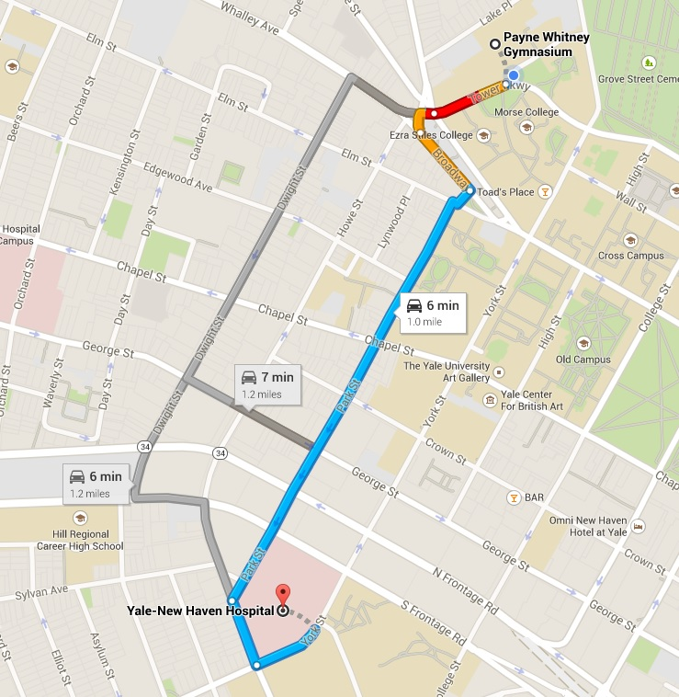

Payne Whitney Gymnasium to YNNH Emergency Room (ER)

Head WEST on TOWER PKWY
Turn LEFT to stay on TOWER PKWY
TOWER PKWY turns SLIGHTLY LEFT and becomes BROADWAY
Turn RIGHT on PARK ST
Turn LEFT on HOWARD AVE
Turn LEFT on YORK ST
EMERGENCY DEPARTMENT is located on the LEFT

Yale University Athletic Training
Emergency Action Plan
Ingalls Rink
73 Sachem St, New Haven, CT 06511

Emergency Personnel: A certified athletic trainer (ATC) is on-site for practices and competitions. Athletic Training Student(s) may be present only when supervised by an ATC. A Physician/PA will be on-site for all home contests.
Emergency Communication: Cell phones and landlines are available in the in the Ingalls Athletic Training Room (ATR) and with the on-site athletic trainer.
Rob Frost (Men’s Hockey ATC) c:(716) 430-1646
Kristin Emerick (Women’s Ice Hockey ATC) c:(203) 274-0194
Police/Fire/EMS 911
Ingalls ATR o:(203) 432-6455
Jeff Torre (Equipment Manager) o: (203) 432-1428 c:(203) 376-7734
Yale New Haven Hospital Emergency Room (203) 688-4242
Yale Security (203) 432-4400

Emergency Equipment: First aid supplies (athletic trainers’ kit and body substance isolation (BSI) bag on-site. Breathing devices, vacuum splints and crutches are available in the Athletic Training Room (ATR). An AED is stationed in a cabinet in the ATR and mounted on the wall on the main concourse. The ATR is located next to the Varsity Locker Rooms. During Varsity Contests the equipment is located next to the home bench.
Roles of Emergency Care Team Members
- Immediate care of the injured/ill student-athlete: Follow appropriate first aid principles (See Injury/Illness Emergency Protocol included with this Emergency Action Plan).
- Emergency equipment retrieval: Appropriate to the emergency
- Activation of emergency medical system (EMS) by calling University Police dispatch at 911.
  - Provide them with the following information:
    - Identify yourself and your role in the emergency
    - Specify your location and telephone number (if calling by phone)
    - Give name(s) of injured/ill individual(s)
    - Condition of victim(s)
    - Time of the incident
    - Care being provided
    - Give specific directions to the scene of the emergency
Direction of EMS to the scene
- Open appropriate doors
- Designate individual to "flag down" EMS on Sachem St and direct to scene
- Scene control: keep non-emergency medical team members away from the scene

Venue Directions: Women’s and Men’s Ice Hockey practices and competitive events are conducted in the Ingalls Rink located at 73 Sachem St, New Haven on the corner of Sachem and Prospect St. Emergency access is located at the front of the building on Sachem St. The elevator is located in the left facing ticket booth. Look for Contest management personnel to guide you to the emergency scene.
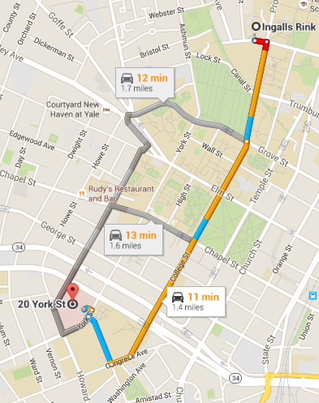

Ingalls Ice Rink to YNHH Emergency Room (20 York St. New Haven, CT 06510)
Directions to Yale New Haven Hospital:
1. Start out going EAST on SACHEM ST toward PROSPECT ST
2. Take the 1st RIGHT onto PROSPECT ST.
3. PROSPECT ST becomes COLLEGE ST.
4. Turn SLIGHT RIGHT onto CONGRESS AVE.
5. Take the 2nd RIGHT onto Howard Ave
6. Take the 1st RIGHT onto YORK ST.
YNHH Emergency Room on Left
Yale University Athletic Training
Emergency Action Plan
Yale Bowl
81 Central Ave, New Haven, CT

Emergency Personnel: A certified athletic trainer (ATC) is on-site for practices and competitive events. Athletic Training Student(s) may be present only when supervised by an ATC. A Physician/PA will be available for all home contests. EMS and ambulance will be present for all home contests 1 hour before and 30 mins after completion of competition.
Emergency Communication: Cell phones and landlines are available in the in the Smilow Athletic Training Room (235 Derby Avenue (ATR) and with the on-site athletic trainer.

Jay Cordone (Head Athletic Trainer) c:(914) 494-9352
Paul Smith (Head Football ATC) c:(860) 834-2731
Jenny Conrad (Football ATC) c:(541) 968-3305

Police/Fire/EMS 911
Smilow ATR o:(203) 764-9235
Yale New Haven Hospital Emergency Room (203) 688-4242
Yale Security (203) 432-4400

Emergency Equipment: AED, First aid supplies, vacuum splints, crutches, on-site for all practices/games. Transport cart available on home team sideline.
Roles of Emergency Care Team Members
- Immediate care of the injured/ill student-athlete: Follow appropriate first aid principles
- Emergency equipment retrieval: Appropriate to the emergency
- Activation of emergency medical system (EMS) by calling University Police dispatch at 911.
  - Provide them with the following information:
    - Identify yourself and your role in the emergency
    - Specify your location and telephone number (if calling by phone)
    - Give name(s) of injured/ill individual(s)
    - Condition of victim(s)
    - Time of the incident
    - Care being provided
    - Give specific directions to the scene of the emergency
Direction of EMS to the scene
- Open appropriate doors/gates (LJJH key will open gates on Yale’s properties)
- Designate individual to "flag down" EMS on Yale Avenue (Gate A) and direct to scene
- Emergency vehicle access to field is thru East Side of Bowl between portals 30 and 1
- Scene control: keep non-emergency medical team members away from the scene

EMERGENCY EVACUATION PLAN YALE BOWL
PURPOSE:
The purpose of this document is to provide a uniform procedure for the evacuation of the Yale Bowl.
PROCEDURE:
The Public Safety Command Post, located adjacent to Gate A, will be staffed by representatives of the Yale University, New Haven, West Haven Police Departments and the New Haven Fire Department.
A ranking Fire Official on scene will serve as Incident Commander and will determine whether a full or partial evacuation is necessary.
If no fire official is on scene, the ranking Police Official will serve as Incident Commander and will determine whether a full or partial evacuation is necessary.
If an evacuation is ordered:
The command post will announce a “Signal 68” condition and order all units to their pre-assigned posts.
Yale Athletics Staff will notify their staff, the PA announcer, game officials and coaches.
Coaches, players and game officials will leave the stadium through their respective tunnels.
Once the game has been stopped, the PA Announcer will make this announcement:
“DUE TO CIRCUMSTANCES BEYOND OUR CONTROL, THE GAME CANNOT BE CONTINUED. PLEASE EXIT THE STADIUM THROUGH THE NEAREST PORTAL”
Police officers will respond to their pre-assigned posts
EMS will deploy to the visitors tunnel and portal 16.
Event staff and ushers will assist with portal egress.
Gates and traffic posts will be staffed.
A secondary medical location will be established at Coxe Cage.
Police resources will be re-assigned, as necessary, to facilitate exiting traffic flow.
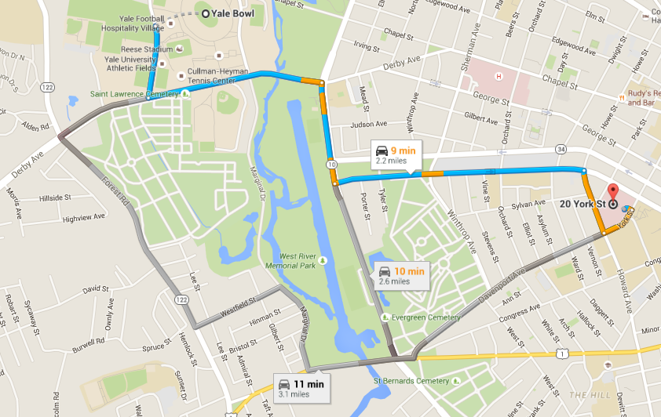

Directions to Yale New Haven Hospital:
1. Start out going SOUTH on YALE Ave
2. Turn LEFT onto DERBY Ave./ CT-34
3. Turn RIGHT onto ELLA GRASSO BLVD/ CT-34/CT-10
4. Turn LEFT onto LEGION Ave./ CT-34
5. Turn RIGHT onto PARK St.
6. Yale New Haven Hospital Destination on LEFT (35 Park St.)

Yale University Athletic Training
Emergency Action Plan
Smilow Field Center
235 Derby Ave, West Haven, CT 06511

Emergency Personnel: A certified athletic trainer (ATC) is on-site for practices and competitive events. Athletic Training Student(s) may be present only when supervised by an ATC.
Emergency Communication: Cell phones and landlines are available in the in the Smilow Athletic Training Room (ATR) and with the on-site athletic trainer.

Jay Cordone (Football, Men’s Lacrosse ATC) c:(914) 494-9352
Paul Smith (Head Football ATC) c:(860) 834-2731
Maggie Maloney (Women’s Soccer, Women’s Lacrosse ATC) c:(617) 820-8253
Jenny Conrad (Football ATC) c:(541) 968-3305
Kristin Emerick (Cross Country, Outdoor Track ATC) c:(203) 274-0194
Brandon McDonald (Baseball ATC) c:(973) 650-9380
Jordan Paolucci (Field Hockey ATC) c:(407) 921-6750
Katelyn Engen (Men’s Soccer, Men’s and Women’s Tennis ATC) c:(240) 997-1173
Kelsey Jensen (Football, Softball ATC) c:(719) 242-5795
Kory Carlson (Men’s and Women’s XC and Track and Field, Baseball ATC) c:(801) 589-4157
Police/Fire/EMS 911
Smilow ATR o:(203) 764-9235
Yale New Haven Hospital Emergency Room (203) 688-4242
Yale Security (203) 432-4400

Emergency Equipment: First aid supplies, athletic trainers’ kit and body substance isolation (BSI) bag, along with breathing devices, vacuum splints and crutches are available in the Athletic Training Room (ATR). An AED is stationed in a marked cabinet labeled AED. The Athletic Training Room is located on the first floor of the Lapham Field House.
Roles of Emergency Care Team Members
- Immediate care of the injured/ill student-athlete: Follow appropriate first aid principles (See Injury/Illness Emergency Protocol included with this Emergency Action Plan).
- Emergency equipment retrieval: Appropriate to the emergency
- Activation of emergency medical system (EMS) by calling University Police dispatch at 911.
  - Provide them with the following information:
    - Identify yourself and your role in the emergency
    - Specify your location and telephone number (if calling by phone)
    - Give name(s) of injured/ill individual(s)
    - Condition of victim(s)
    - Time of the incident
    - Care being provided
    - Give specific directions to the scene of the emergency
Direction of EMS to the scene
- EMS will arrive to 235 Derby Ave, Lapham Field House/ Smilow Athletic Complex
- Designate individual to "flag down" EMS and direct to scene
- Scene control: keep non-emergency medical team members away from the scene

Directions to Yale New Haven Hospital From Smilow Field House

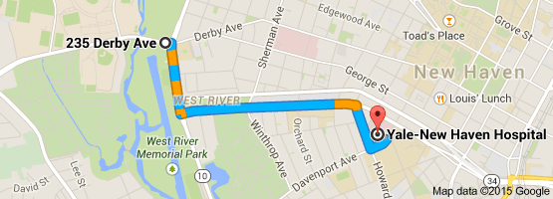

1. Head East (Left) on Derby Avenue towards Ella T Grasso Boulevard
2. Turn right onto Ella T Grasso Boulevard
3. Turn Left onto Legion Avenue
4. Turn Right onto Howard Avenue
5. Turn Left onto York Street
YNHH Emergency Room on LEFT

Yale University Athletic Training
Emergency Action Plan
Coxe Cage/Cullman Tennis Center
257-279 Derby Avenue, New Haven, CT 06515

Emergency Personnel: A certified athletic trainer (ATC) is on-site for practices and competitive events. Athletic Training Student(s) may be present only when supervised by an ATC. A Physician / PA will be available for all home contests.
Emergency Communication: Cell phones and land lines are available in the in the Smilow Athletic Training Room (ATR) and with the home athletic trainer.

Kristin Emerick (Men’s and Women’s XC, Outdoor Track and Field ATC) c:(203) 274-0194
Kory Carlson (Men’s and Women’s XC, Indoor Track and Field ATC) c:(801) 589-4157
Katelyn Engen (Men’s and Women’s Tennis ATC) c:(240) 997-1173

Police/Fire/EMS 911
Smilow ATR o:(203) 764-9235
Yale New Haven Hospital Emergency Room (203) 688-4242
Yale Security (203) 432-4400

Emergency Equipment: First aid supplies (athletic trainers’ kit and body substance isolation (BSI) bag on-site. Breathing devices, vacuum splints and crutches are available in the Athletic Training Room (ATR). An AED is stationed in a marked cabinet labeled AED. The Athletic Training Room is located in Smilow Field Center on the first floor.
Roles of Emergency Care Team Members
- Immediate care of the injured/ill student-athlete: Follow appropriate first aid principles (See Injury/Illness Emergency Protocol included with this Emergency Action Plan).
- Emergency equipment retrieval: Appropriate to the emergency
- Activation of emergency medical system (EMS) by calling University Police dispatch at 911.
  - Provide them with the following information:
    - Identify yourself and your role in the emergency
    - Specify your location and telephone number (if calling by phone)
    - Give name(s) of injured/ill individual(s)
    - Condition of victim(s)
    - Time of the incident
    - Care being provided
    - Give specific directions to the scene of the emergency
Direction of EMS to the scene
- EMS will arrive via 251-257 Derby Ave, New Haven Fields leading to Coxe Cage and Cullman Tennis Courts
- Designate individual to "flag down" EMS and direct to scene
- Scene control: keep non-emergency medical team members away from the scene

Directions to Yale New Haven Hospital From Smilow Field House

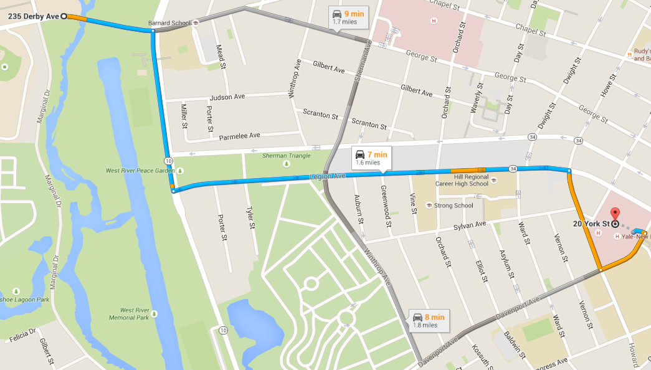

1. Head East on Derby Avenue towards Ella T Grasso Boulevard
2. Turn right onto Ella T Grasso Boulevard
3. Turn Left onto Legion Avenue
4. Turn Right onto Howard Avenue
5. Turn Left onto York Street
YNHH Emergency Room on LEFT

Yale University Athletic Training
Emergency Action Plan
Dewitt-Cuyler/Clinton-Frank Complex
252 Derby Avenue, West Haven, CT 06516

Emergency Personnel: A certified athletic trainer (ATC) is on-site for practices and competitive events. Athletic Training Student(s) may be present only when supervised by an ATC. A Physician / PA will be available for all home contests.
Emergency Communication: Cell phones and landlines are available in the in the Smilow Athletic Training Room (ATR) and with the on-site athletic trainer.

Jay Cordone (Football, Men’s Lacrosse ATC) c:(914) 494-9352
Paul Smith (Head Football ATC) c:(860) 834-2731
Jennifer Conrad (Football ATC) c:(541) 968-3305

Police/Fire/EMS 911
Smilow ATR o:(203) 764-9235
Yale New Haven Hospital Emergency Room (203) 688-4242
Yale Security (203) 432-4400

Emergency Equipment: First aid supplies (athletic trainers’ kit and body substance isolation (BSI) bag on-site. Breathing devices, vacuum splints and crutches are available in the Athletic Training Room (ATR). An AED is stationed in a marked cabinet labeled AED and on-site during scheduled practices and competitions. The Athletic Training Room is located in Smilow Field Center (235 Derby Avenue) on the first floor.
Roles of Emergency Care Team Members
- Immediate care of the injured/ill student-athlete: Follow appropriate first aid principles (See Injury/Illness Emergency Protocol included with this Emergency Action Plan).
- Emergency equipment retrieval: Appropriate to the emergency
- Activation of emergency medical system (EMS) by calling University Police dispatch at 911.
  - Provide them with the following information:
    - Identify yourself and your role in the emergency
    - Specify your location and telephone number (if calling by phone)
    - Give name(s) of injured/ill individual(s)
    - Condition of victim(s)
    - Time of the incident
    - Care being provided
    - Give specific directions to the scene of the emergency
Direction of EMS to the scene
- EMS will arrive via 258 Derby Ave, West Haven Fields South Access to left and behind Yale Field
  - If gates are locked, LJJH key will unlock padlocks on access routes
- Designate individual to "flag down" EMS and direct to scene
- Scene control: keep non-emergency medical team members away from the scene

Directions to Yale New Haven Hospital From Dewitt-Cuyler/Clint Frank Complex

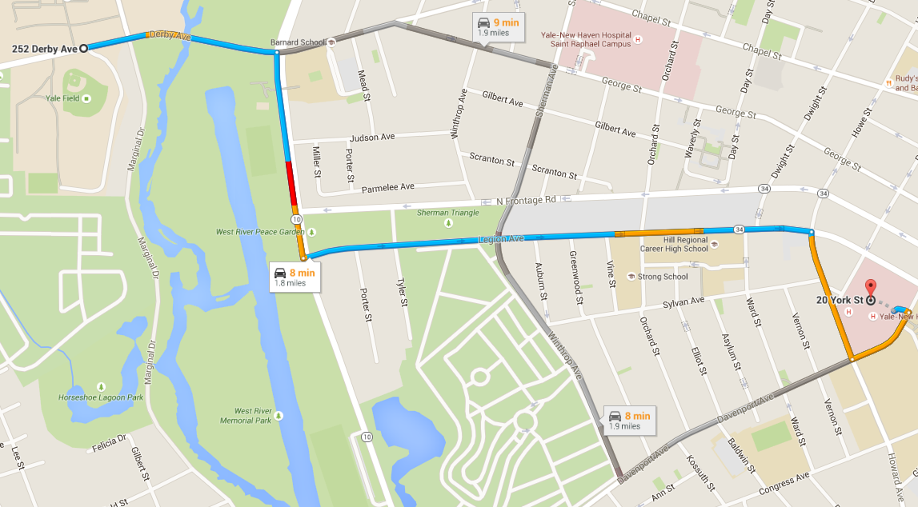

1. Continue on to CT-34E Derby Avenue
2. Turn Right onto Ella T Grasso Boulevard
3. Turn Left onto Legion Avenue
4. Turn Right onto Howard Avenue
5. Turn Left onto York Street
YNHH Emergency Room on LEFT

Yale University Athletic Training
Emergency Action Plan
Dewitt Family Field (Softball)
70 Central Avenue, New Haven, CT 06515

Emergency Personnel: A certified athletic trainer (ATC) is on-site for practices and competitive events. Athletic Training Student(s) may be present only when supervised by an ATC.
Emergency Communication: Cell phones and landlines are available with the home athletic trainer as well as in the Dewitt Family Field Press Box.

Kelsey Jensen (Softball ATC) c:(719) 242-5795

Police/Fire/EMS 911
Smilow ATR o:(203) 764-9235
Yale New Haven Hospital Emergency Room (203) 688-4242
Yale Security (203) 432-4400

Emergency Equipment: First aid supplies (athletic trainers’ kit and body substance isolation (BSI) bag) on-site. Breathing devices, vacuum splints and crutches are available in the Athletic Training Room (ATR). An AED, if not already out at the field, is stationed in a locked box (LJJH key) between softball field and field hockey stadium. The ATR is located on the first floor of Smilow Field Center (235 Derby Avenue). During Varsity Contests, the equipment is located on the home bench.
Roles of Emergency Care Team Members
- Immediate care of the injured/ill student-athlete: Follow appropriate first aid principles
- Emergency equipment retrieval: Appropriate to the emergency
- Activation of emergency medical system (EMS) by calling dispatch at 911.
  - Provide them with the following information:
    - Identify yourself and your role in the emergency
    - Specify your location and telephone number (if calling by phone)
    - Give name(s) of injured/ill individual(s)
    - Condition of victim(s)
    - Time of the incident
    - Care being provided
    - Give specific directions to the scene of the emergency
Direction of EMS to the scene
- Open appropriate doors/gates (LJJH key for locked gates on access route)
- Designate individual to "flag down" EMS on Central Ave at end of parking lot entrance and direct to scene
- Scene control: keep non-emergency medical team members away from the scene

*Dewitt Family Field is located on Central Ave (off of Derby Ave) accessible through the 1st entrance on the left to the parking lot. Contest manager should be at the end of the parking lot to direct the ambulance down the pathway to the field.
Yale University Athletic Fields to YNHH Emergency Room
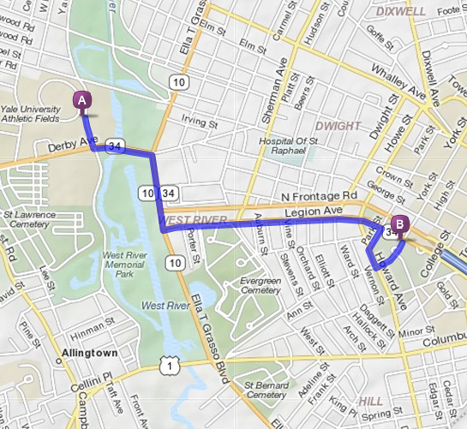

Outdoor Yale Fields to Yale New Haven Hospital Emergency Room
1. Start out going SOUTH on CENTRAL AVE toward DERBY AVE/CT-34. 0.2 mi
2. Take the 1st LEFT onto DERBY AVE/CT-34.
3. Take the 1st RIGHT onto ELLA T GRASSO BLVD/CT-10/CT-34.
4. Turn LEFT onto LEGION AVE/CT-34 E. Continue to follow CT-34 E.
5. Turn RIGHT onto PARK ST.
6. Turn SLIGHT LEFT onto HOWARD AVE.
7. Take the 1st LEFT onto YORK ST.
EMERGENCY ROOM IS LOCATED ON THE LEFT.

Yale University Athletic Training
Emergency Action
Yale Field (Baseball)
252 Derby Avenue, West Haven, CT 06516

Emergency Personnel: A certified athletic trainer (ATC) is on-site for practices and competitions. Athletic Training Student(s) may be present only when supervised by an ATC.
Emergency Communication: Cell phones and landlines are available in the Baseball Clubhouse located in left field, in the in the Smilow Athletic Training Room (235 Derby Avenue), and with the on-site athletic trainer.

Brandon McDonald (Baseball ATC) c:(973) 650-9380
Kory Carlson (Baseball ATC) c:(801) 589-4157

Police/Fire/EMS 911
Smilow ATR o:(203) 764-9235
Yale New Haven Hospital Emergency Room (203) 688-4242
Yale Security (203) 432-4400

Emergency Equipment: First aid supplies (athletic trainers’ kit and body substance isolation (BSI) bag) on-site. Breathing devices, vacuum splints and crutches are on-site for competitions; otherwise, they will be available in the Smilow Athletic Training Room (ATR). An AED is stationed in a cabinet inside the baseball team clubhouse. The Smilow ATR is located across the street at 235 Derby Ave.
Roles of Emergency Care Team Members
- Immediate care of the injured/ill student-athlete: Follow appropriate first aid principles
- Emergency equipment retrieval: Appropriate to the emergency
- Activation of emergency medical system (EMS) by calling University Police dispatch at 911.
  - Provide them with the following information:
    - Identify yourself and your role in the emergency
    - Specify your location and telephone number (if calling by phone)
    - Give name(s) of injured/ill individual(s)
    - Condition of victim(s)
    - Time of the incident
    - Care being provided
    - Give specific directions to the scene of the emergency
Direction of EMS to the scene
- Open Left Field Fence (LJJH key) to allow EMS access to the field
- Designate individual to "flag down" EMS on Derby Ave and direct to scene
- Scene control: keep non-emergency medical team members away from the scene

Venue Directions: Baseball practice and competitive events are conducted at Yale Field at 252 Derby Ave West Haven CT. Emergency access is located next to the left field foul pole (LJJH key if gate is locked). Look for Contest management personnel to guide you to the emergency scene.
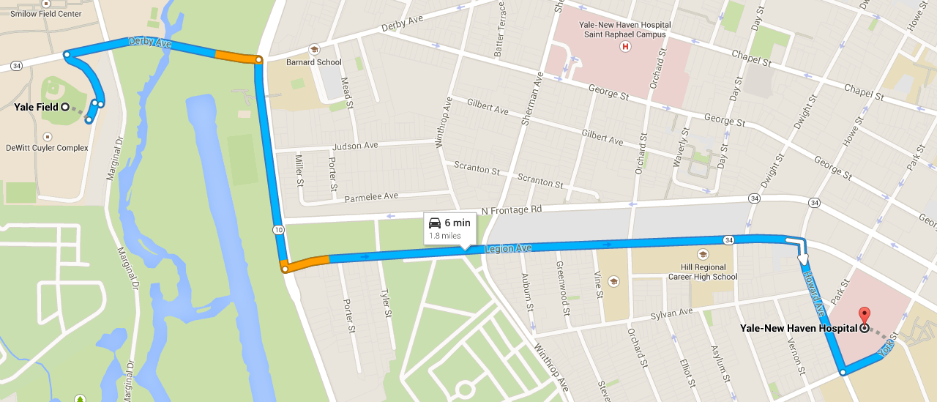

Directions to Yale New Haven Hospital (20 York St, New Haven, CT):
1. Start out heading EAST on Derby Ave toward Ella T Grasso Blvd
2. Turn RIGHT onto Ella T Grasso Blvd at second set of lights, travel 0.3miles
3. Turn LEFT onto Legion Ave, travel 0.8miles
4. Turn RIGHT onto Howard Ave, travel 0.2miles
5. Turn LEFT onto York St, travel 500ft
YNHH Emergency Room on Left

Yale University Athletic Training
Emergency Action Plan
Johnson Field (Field Hockey)
70 Central Avenue, New Haven, CT 06515

Emergency Personnel: A certified athletic trainer (ATC) is on-site for practices and competition. Athletic Training Student(s) may be present only when supervised by an ATC. A physician/PA will be on-site for home contests.
Emergency Communication: Cell phones and landlines are available in the Johnson Field Press Box, in the Smilow Athletic Training Room (ATR), and with the on-site athletic trainer.

Jordan Paolucci (Field Hockey ATC) c:(407) 921-6750

Police/Fire/EMS 911
Smilow ATR o:(203) 764-9235
Yale New Haven Hospital Emergency Room (203) 688-4242
Yale Security (203) 432-4400

Emergency Equipment: First aid supplies (athletic trainers’ kit and body substance isolation (BSI) bag) on-site. Breathing devices, vacuum splints and crutches are available in the Athletic Training Room (235 Derby Avenue). An AED, if not already out at the field, is stationed in a locked box (LJJH key) on a marked pole outside Johnson Field. During Varsity Contests, the equipment is located on the home sideline.
Roles of Emergency Care Team Members
- Immediate care of the injured/ill student-athlete: Follow appropriate first aid principles (See Injury/Illness Emergency Protocol included with this Emergency Action Plan).
- Emergency equipment retrieval: Appropriate to the emergency
- Activation of emergency medical system (EMS) by calling dispatch at 911.
  - Provide them with the following information:
    - Identify yourself and your role in the emergency
    - Specify your location and telephone number (if calling by phone)
    - Give name(s) of injured/ill individual(s)
    - Condition of victim(s)
    - Time of the incident
    - Care being provided
    - Give specific directions to the scene of the emergency
Direction of EMS to the scene
- Open appropriate doors/gates (LJJH key for access to locked access roads)
- Designate individual to "flag down" EMS on Central Ave at end of parking lot entrance and direct to scene
- Scene control: keep non-emergency medical team members away from the scene

*Johnson Field is located on Central Ave (off of Derby Ave) accessible through the entrance to the parking lot.
Yale University Athletic Fields to YNHH Emergency Room
Outdoor Yale Fields to Yale New Haven Hospital Emergency Room
1. Start out going SOUTH on CENTRAL AVE toward DERBY AVE/CT-34. 0.2 mi
2. Take the 1st LEFT onto DERBY AVE/CT-34.
3. Take the 1st RIGHT onto ELLA T GRASSO BLVD/CT-10/CT-34.
4. Turn LEFT onto LEGION AVE/CT-34 E. Continue to follow CT-34 E.
5. Turn RIGHT onto PARK ST.
6. Turn SLIGHT LEFT onto HOWARD AVE.
7. Take the 1st LEFT onto YORK ST. EMERGENCY ROOM IS LOCATED ON THE LEFT.

Yale University Athletic Training
Emergency Action Plan
Reese Stadium (Soccer, Lacrosse)
75 Central Ave, New Haven, CT 06511

Emergency Personnel: A certified athletic trainer (ATC) is on-site for practices and competitive events. Athletic Training Student(s) may be present only when supervised by an ATC. A Physician / PA will be available for all home contests.
Emergency Communication: Cell phones and landlines are available in the Reese Stadium Press Box, in the in the Smilow Athletic Training Room (ATR), and with the on-site athletic trainer.

Jay Cordone (Head Athletic Trainer, Men’s Lacrosse ATC) c:(914) 494-9352
Maggie Maloney (Women’s Soccer, Women’s Lacrosse ATC) c:(617) 820-8253
Katelyn Engen (Men’s Soccer ATC) c:(240) 997-1173

Police/Fire/EMS 911
Smilow ATR o:(203) 764-9235
Yale New Haven Hospital Emergency Room (203) 688-4242
Yale Security (203) 432-4400

Emergency Equipment: AED, First aid supplies, vacuum splints, crutches, on-site for all practices/games.
Roles of Emergency Care Team Members
- Immediate care of the injured/ill student-athlete: Follow appropriate first aid principles
- Emergency equipment retrieval: Appropriate to the emergency
- Activation of emergency medical system (EMS) by calling University Police dispatch at 911.
  - Provide them with the following information:
    - Identify yourself and your role in the emergency
    - Specify your location and telephone number (if calling by phone)
    - Give name(s) of injured/ill individual(s)
    - Condition of victim(s)
    - Time of the incident
    - Care being provided
    - Give specific directions to the scene of the emergency
Direction of EMS to the scene
- Open appropriate doors/gates (LJJH key will unlock padlocks)
- Designate individual to "flag down" EMS on Yale Avenue (Gate A) and direct to scene
- Emergency vehicle access to field is thru East Side of Bowl between portals 30 and 1
- Scene control: keep non-emergency medical team members away from the scene

Yale University Athletic Fields to YNHH Emergency Room
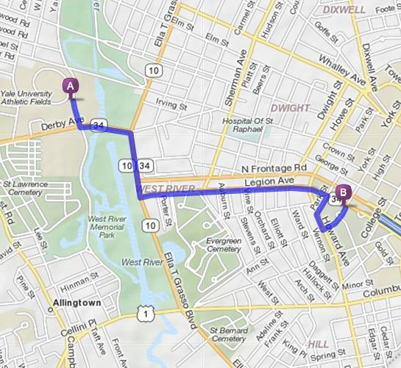

Outdoor Yale Fields to Yale New Haven Hospital Emergency Room
1. Take the 1st LEFT onto DERBY AVE/CT-34.
2. Take the 1st RIGHT onto ELLA T GRASSO BLVD/CT-10/CT-34.
3. Turn LEFT onto LEGION AVE/CT-34 E. Continue to follow CT-34 E.
4. Turn RIGHT onto PARK ST.
5. Turn SLIGHT LEFT onto HOWARD AVE.
6. Take the 1st LEFT onto YORK ST. EMERGENCY ROOM LOCATED ON THE LEFT

Yale University Athletic Training
Emergency Action Plan
Gilder Boathouse (Women’s Crew, Lightweight Crew, Heavyweight Crew)
280 Roosevelt Drive, Derby, CT 06418

Emergency Personnel: A certified athletic trainer (ATC) is on-site for competitive events only. Athletic Training Student(s) may be present only when supervised by an ATC.
Emergency Communication: Cell phones and landlines are available in the coaches’ office and with the on-site athletic trainer.

Jordan Paolucci (Women’s Crew ATC) c:(407) 921-6750
Lindsay Snecinski (Men’s Crew ATC) c:(203) 464-8848
Nicole Payne (Women’s Crew ATC) c:(914) 522-5212

Police/Fire/EMS 911
Yale New Haven Hospital Emergency Room (203) 688-4242
Yale Security (203) 432-4400

Emergency Equipment: First aid supplies (athletic trainers’ kit and body substance isolation (BSI) bag) on-site. An AED is located downstairs in the supply room next to the boats where the coaches’ gear is located.
Roles of Emergency Care Team Members
- Immediate care of the injured/ill student-athlete: Follow appropriate first aid principles (See Injury/Illness Emergency Protocol included with this Emergency Action Plan).
- Emergency equipment retrieval: Appropriate to the emergency
- Activation of emergency medical system (EMS) by calling dispatch at 911.
  - Provide them with the following information:
  - Identify yourself and your role in the emergency
  - Specify your location and telephone number (if calling by phone)
  - Give name(s) of injured/ill individual(s)
  - Condition of victim(s)
  - Time of the incident
  - Care being provided
  - Give specific directions to the scene of the emergency
Direction of EMS to the scene
- Open appropriate doors/gates
- Designate individual to "flag down" EMS on Roosevelt Drive at end of parking lot entrance and direct to scene
- Scene control: keep non-emergency medical team members away from the scene

Gilder Boathouse to YNHH Emergency Room

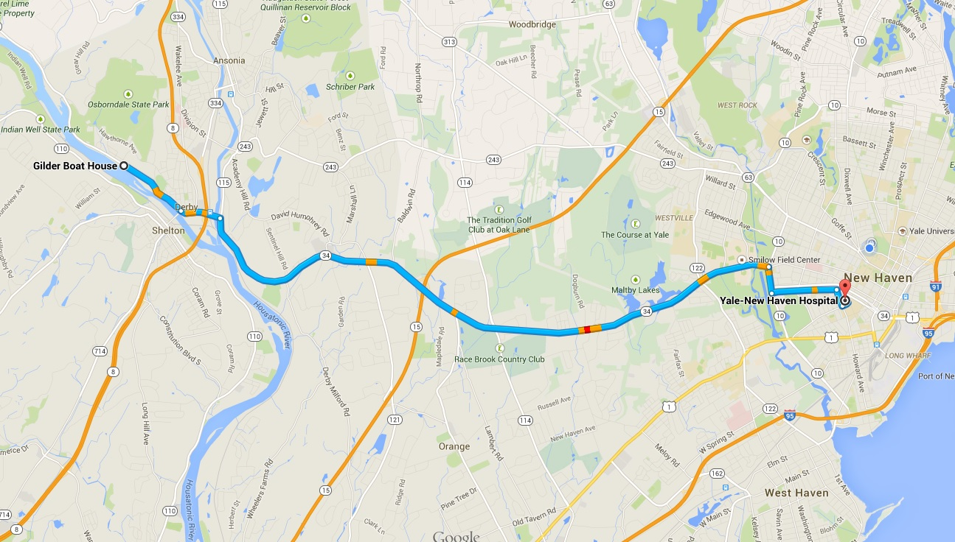

Directions to YNNH ER from Gilder Boathouse

1. Head SOUTHEAST on ROOSEVELT toward D ST
2. Continue onto MAIN ST
3. Turn RIGHT onto CT-34 E/DERBY AVE
4. Turn RIGHT onto ELLA T GRASSO BLVD
5. Turn LEFT onto LEGION AVE
6. Turn RIGHT onto HOWARD AVE
7. Turn LEFT onto YORK ST
Emergency Room will be on the LEFT

Lightning Safety Policy and Procedure
- All outdoor activities will be suspended at the first sound of thunder, the first sign of lightning, or when the Televent Message system has warned of lightning in the immediate vicinity (6 mile radius).

- If a Certified Athletic Trainer is NOT present during outdoor athletic activity, coaches/officials/athletes must use the Flash-Bang method for determining distance of approaching storm.
  - Count the seconds between seeing lightning flash and hearing the bang of thunder. Then divide by five to determine how far away in miles the lightning activity is occurring. Be inside a safe structure by the time the count approaches 30 seconds (six miles).
- Once it has been determined there is lightning approaching and it is within a dangerous distance, a member of the Sports Medicine Staff will notify coaches and athletes to vacate the fields.
2. Once outdoor activity has been suspended, all personnel (ATC, coaches, & athletes) must immediately seek safe shelter.
- Coxe Cage
- Reese Team Rooms
- Baseball Offices/Clubhouse
- Yale Bowl Offices/ Team Half-time Rooms
- Tennis Center
3. Outdoor activities can be resumed 30 minutes following the last sound of thunder or the last flash of lightning. No exceptions!!!
- Yale University Sports Medicine Staff will determine when it is safe to return to activity.
- ** During Competition, Yale Sports Medicine Staff will discuss with official game personnel to determine when it is safe to resume competition.
General Recommendations Regarding Lightning Safety
(Taken from the NATA Recommendations for Lightning Safety)
1. Avoid being the highest point in an open field, in contact with or proximity to the highest point, as well as being on open water. Do not take shelter under or near trees, flagpoles, or light poles.
2. Assume the lightning safe position (crouched on the ground, weight on the balls of the feet, feet together, head lowered, and ears covered) for individuals who feel their hair stand on end, skin tingle, or hear “crackling” noise. Do not lay flat on the ground.
3. Observe the following basic first aid procedures in managing victims of a lightning strike:
- Survey the scene for safety.
- Activate local EMS.
- Lightning victims do not ‘carry a charge’ and are safe to touch.
- If necessary, move the victim with care to a safer location.
- Evaluate airway, breathing, and circulation, and begin CPR if necessary.
- Evaluate and treat for hypothermia, shock, fractures, and/or burns.
4. It is not safe to shower, bathe or talk on landline phones while inside of a safe shelter during thunderstorms (cell phones are ok).

All individuals have the right to leave an athletic site in order to seek a safe structure if the person feels in danger of impending lightning activity, without fear of repercussions or penalty from anyone.

EXTREME WEATHER POLICY
Here at Yale University, the Sports Medicine department uses a variety of different resources when it comes to Extreme Weather Exposure recommendations for its athletes. Our goal is to provide a safe environment for our entire student athlete population during Colder & Hotter than normal temperatures. Collectively as a Sports Medicine staff, along with our team physicians, coaches, and athletic administrators, we aim to make smart decisions using the NATA Position Statement, NCAA recommendations, the Weather Channel, and Televent weather systems in determining what temperatures are unsafe for athletic participation outdoors, as well as any practice modifications that need to be made due to extreme weather conditions. Below you will find our recommendations and guidelines for Cold and Hot Weather Policies at Yale University. Additional information has also been provided regarding Cold and Heat Illnesses, which use of this policy is intended to prevent.
Why do we care about temperature when it comes to athletes? Any warm object, like a human being, will lose or gain heat. During athletic activity, athletes loose heat to the surrounding area. The difference between people and inanimate objects is that we feel or sense the heat loss. A temperature we feel is called a sensible temperature. You've probably noticed that some days feel colder than others when there is a strong wind blowing, even if the temperatures are the same. The same goes for when you feel warmer if the humidity is higher.
It is important to remember that each sport is different when it comes to pre-season, in-season, and post-season schedules. We have to keep in mind that equipment needs for all sports are different, (i.e. heat related illnesses during football due to helmet and pads are going to be different than field hockey, which does not have any equipment).

Extreme Cold Weather Illness
Why should we care about wind chill? A lower wind chill can increase the rate at which certain cold-weather dangers, such as frostbite and hypothermia can develop. There are precautions that we can take to avoid them when outside in extreme weather, such as wearing proper clothing and using appropriate equipment. You can also check yourself regularly for wet or cold areas on your body while outside in extreme weather, or use the buddy system to look for signs of danger and rewarm body parts as needed. Here are some of the conditions that can lead to hypothermia:
- Cold temperatures
- Wetness
- Poor food intake
- Improper dress/equipment
- Exposed skin
- Prolonged exposure
The severity of hypothermia can vary, depending on how low the core body temperature gets. There are specific signs and symptoms to look for. The condition worsens as the core body temperature lowers.
Mild Hypothermia (core body temperature ranges from 99-95 degrees Fahrenheit):
- Involuntary shivering
- Inability to perform complex motor functions
Moderate Hypothermia (core body temperature ranges from 95-90 degrees Fahrenheit):
- Slurred speech
- Violent shivering
- Dazed consciousness
- Irrational behavior (for example, the person may begin undressing and is unaware of being cold)
- Loss of fine motor coordination
Severe Hypothermia (core body temperature ranges from 90-75 degrees Fahrenheit):
- Pupils are dilated
- Skin is pale
- Pulse rate decreases
- Muscle rigidity develops
- Shivering occurs in waves, it is violent and then pauses; the pauses eventually grow longer and longer until shivering ceases
- Person falls to the ground and cannot walk; may curl into a fetal position to conserve heat
- Person loses consciousness, heartbeat and respiration are erratic
- Cardiac and respiratory failure, then death

Cold Exposure Policy
In cold weather temperatures proper-layered clothing should be worn and encouraged by Yale University Athletics department staff and coaches. These include:
- Several layers around the core of the body, especially for those individuals that are not very active
- Long pants designed to insulate. Cotton sweatpants (Yale issued gear) are excellent. On very cold days a nylon shell or wind pant can be worn on top of them for additional wind break.
- Long sleeve shirt/sweatshirt/coat designed to insulate and break the wind
- Gloves
- Ear protection/hat or helmet
- Face protection
- Wicking socks that do not hold moisture inside. Wool is excellent. Cotton absorbs and holds in moisture
Clothing should be layered to allow adjustments as activity level may increase and decrease within a practice that may elevate or drop body temperature. The first layer of clothing should wick sweat and moisture away from the body. Equipment managers can identify what clothing works best for this. You may have already been issued an excellent product that will act as a wick. The top layers should act as insulators to trap heat and block wind.
The following temperature guidelines have been established for intercollegiate teams during cold weather. Cold weather is defined as any temperature that can negatively affect the body’s regulatory system. These do not have to be freezing temperatures! The following guidelines have been established for Yale University Athletics practice and event participation.
See attached Yale University Athletics Cold Exposure Guidelines for outdoor exposure time based on temperature.

Please note:
- If an event is canceled due to cold exposure concerns there will be no outdoor participation permitted.
- Decisions regarding participation restrictions may be made on an individual basis upon current conditions.
In addition to the above guidelines, it is recommended that additional directives be given to student athletes:
- Inactive student athletes should have the opportunity to remain indoors or have rewarming option.
- Cold exposure/activity requires more energy from a body. Additional calorie intake may be required.
- Cold exposure/activity requires similar hydration to room temperature; however, the thirst reflex is not activated. Conscious efforts before and after practice to hydrate should be initiated.
- Never train alone. A simple ankle sprain in cold weather may become life threatening!
- Student athletes should be instructed on signs of cold stress (wind chill, frostbite and hypothermia). Fatigue, confusion, slurred speech, red or painful extremities, swollen extremities, blurred vision, red watery eyes, dizziness, headache, numbness, tingling of skin and extremities, shivering, uncontrollable shivering etc. are a few warning signs of cold stress.

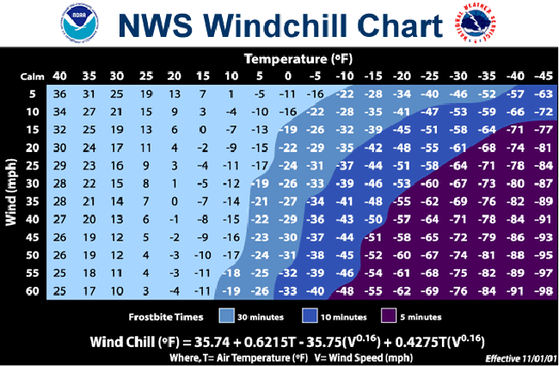

Yale University Athletics Cold Exposure Guidelines
Temperature  Real Feel (F) | Allowable Outdoor Exposure Time (Maximum)  No Precipitation Active Precipitation |  | Participant Attire | Participant Activity | Warm Up/Cool down Location
20° - 16° | No restrictions | 1.5 hours | Long sleeves, pants, gloves, hats | No restrictions | No restrictions
15° - 11° | 1.5 hours | 1 hour | Long sleeves, pants, gloves, hats, exposed skin covered, wicking layer close to skin# | Decrease down time between and during drills/activity | Indoor recommended*
10° - 1° | 1 hour | No outdoor activity | Long sleeves, pants, gloves, hats, exposed skin covered, wicking layer close to skin# | Decrease down time between and during drills/activity | Indoor required
≤ 0° | No outdoor activity | No outdoor activity | N/A | N/A | N/A
* Indoor recommended: Should indoor space not be available, outdoor warm up time will count towards total outdoor exposure time.
(Total outdoor exposure time = outdoor warm up time + outdoor practice time)
# If precipitation persists outer layers will become saturated and cool the participant at a faster rate.

Heat Exposure Policy
When heat and humidity reach certain levels, serious consequences can result from heat stroke. With prevention being the major goal of Yale Sports Medicine and the Athletics Department, it is important certain safeguards are met to ensure the safety of our student athletes.
During times of hot weather, a member of the Sports Medicine Staff will be notified using the Televent System if the temperature & humidity reach a danger zone. This will be used in conjunction with local heat index information available on The Weather Channel website. Even when a particular sport has athletic trainer coverage, it is in the best interest of the head coach to obtain information pertaining to heat/humidity and follow appropriate procedures for each zone or risk.
"Extreme Caution" – Special observation and consideration should be given to student athletes susceptible to heat problems (i.e. overweight, underweight due to water loss, history of previous heat injury). Cold water should be accessible before, during, and after activity.
"Danger" – We strongly encourage several 5-10 minute rest/water breaks for activity lasting over one hour (maximum of 30 minutes between breaks). It is recommended practice should be conducted during the coolest part of the day (before 10 am and after 4 pm). Practice intensity should be light with student-athletes wearing loose, light colored clothing.
“Extreme Danger” – We strongly encourage providing unlimited water breaks every 15 minutes. Practice intensity and duration should be decreased. Practice should be conducted in shorts with no equipment. Consider postponing the practice or event.

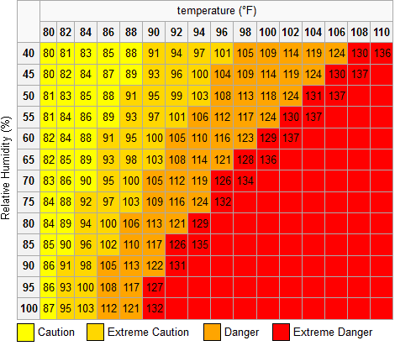

HEAT STROKE SIGNS AND SYMPTOMS
 | HEAT EXHAUSTION | HEAT STROKE
FACE | Pale | Red, Flushed
SKIN | Moist, Clammy | Hot, Dry
SWEATING | Profuse | None
TEMPERATURE | Normal (98.6°F or slightly higher) | Extremely high (106-110°F)
PULSE | Weak and Rapid | Strong and Rapid
CONSCIOUSNESS | Usually conscious | Possibly unconscious, headache a usual symptom
BREATHING | Rapid, shallow | Possible convulsions/ Rapid, shallow
TREATMENT/ FIRST AID | Move to a cool area.  Recline with feet elevated. Ice or cold compresses. Electrolyte solution.  Hospital or Doctor evaluation | Lower body core temperature immediately!  Recline with head elevated. No stimulants  Undress/cold towels or ice/medical emergency transport

