Recording and Sharing Home Blood Pressure Readings with your Provider in MyChart

1. Log into MyChart (mychart.ynhhs.org)
2. Go to the "Health" tab at the top.
3. Select "Track My Health" on the right.

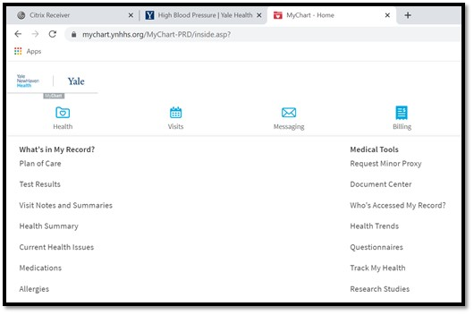
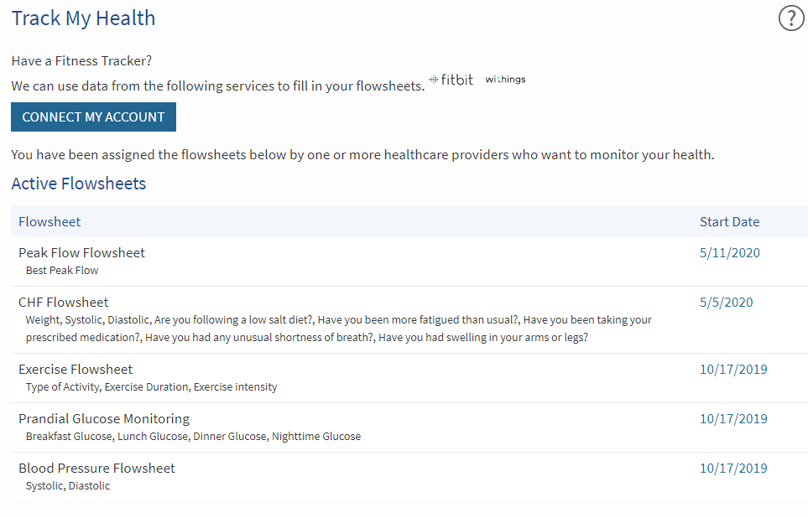
4. Find the "Blood Pressure Flowsheet" and double click to open it.

5. After you take your blood pressure, enter the date, time and the systolic (top) and diastolic (bottom) numbers on the flowsheet and click “Continue.”
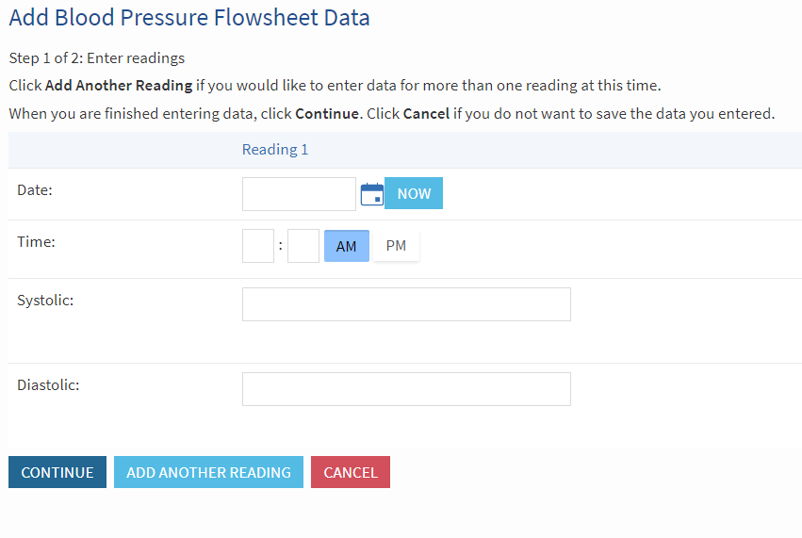

6.
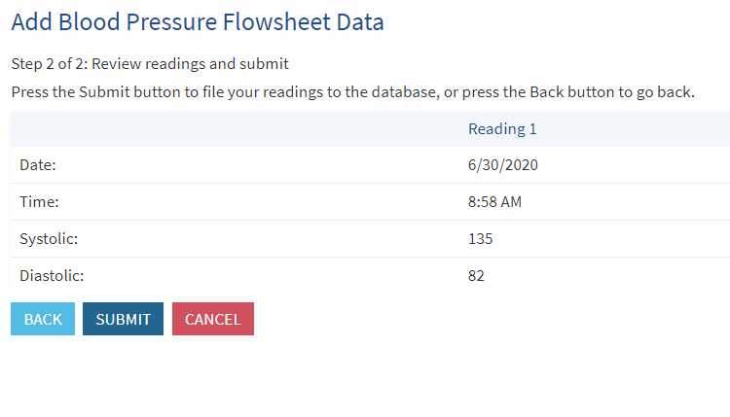
6. Review your readings and click “Submit.”

